Install DSM

DSM: device support module (DSM) recieves events for parsing and normalizing to a standard taxonomy format.

1) access the qradar VM console from host machine using ssh

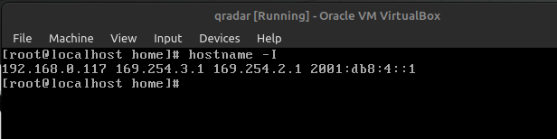

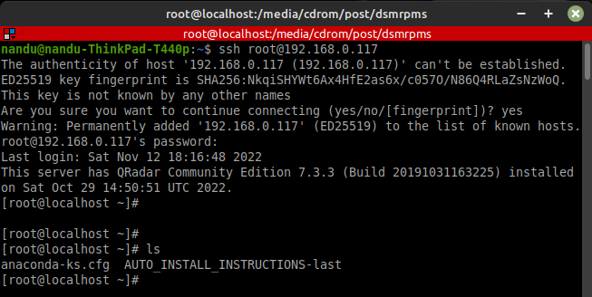

2) mount the iso file

sudo mount -o loop /opt/ibm/cloud/iso/QRadarCE2019_14_0_20191031163225.GA.iso /media/cdrom/



3) list the available DSM.

Go to location /media/cdrom/dsmrpms

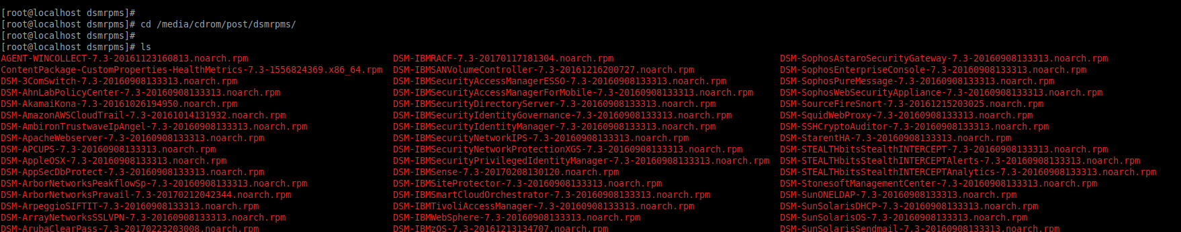

4) install the required DSM.

e.g

yum -y install DSM-ImpervaIncapsula-7.3-20170405130625.noarch.rpm

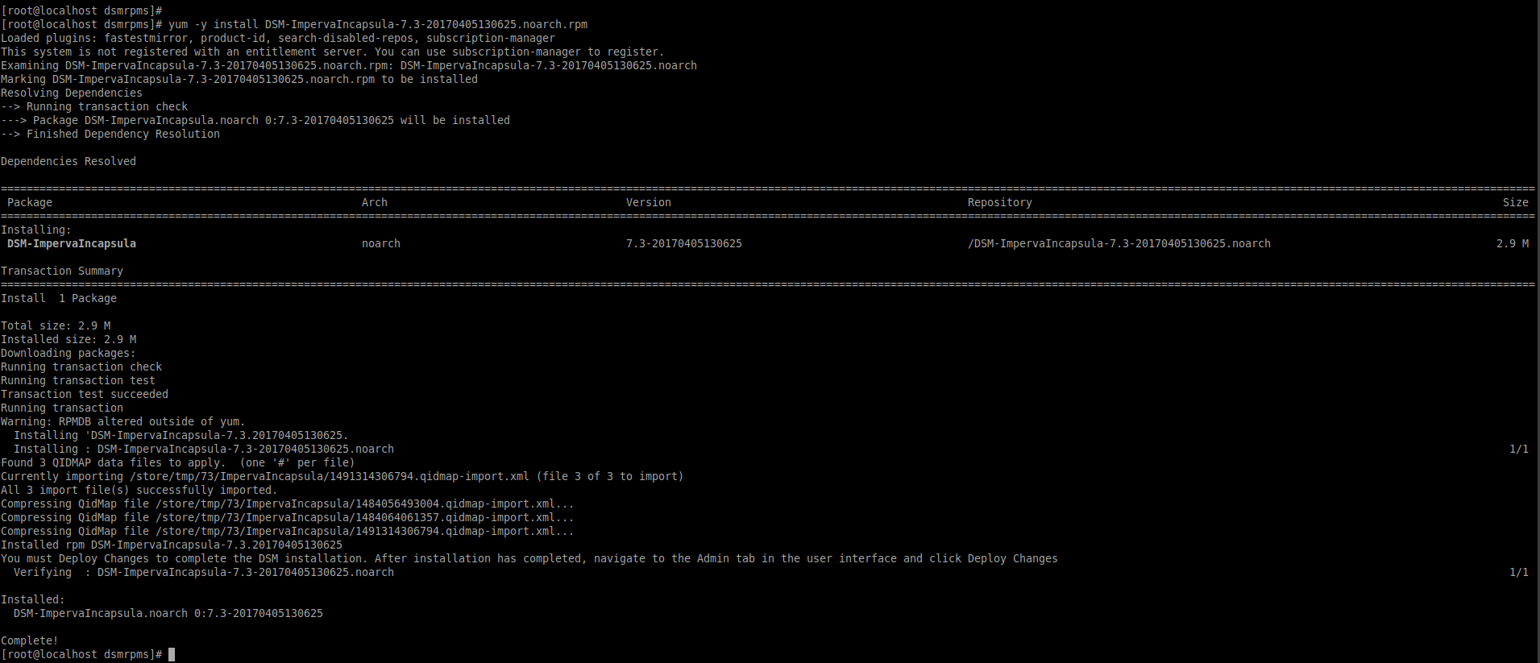

e.g: install amazon cloud trail

some times the dependecy for the package has to be installed before the DSM

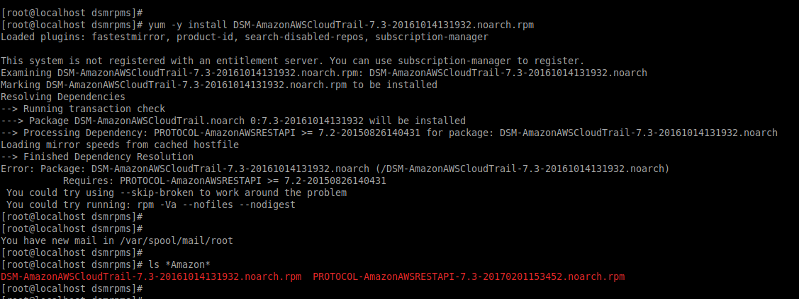

yum -y install PROTOCOL-AmazonAWSRESTAPI-7.3-20170201153452.noarch.rpm

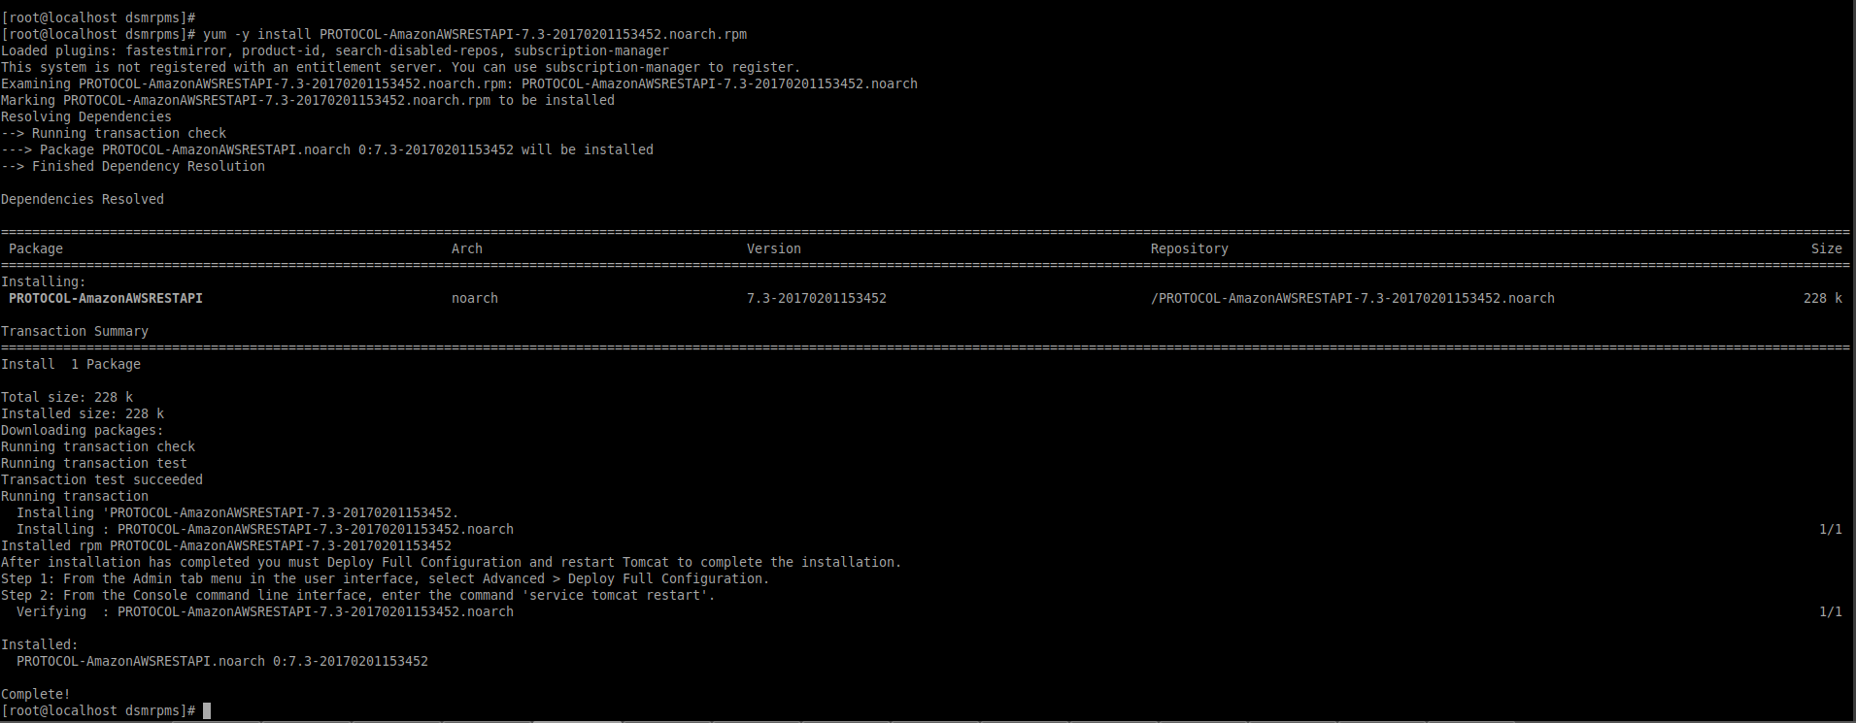

yum -y install DSM-AmazonAWSCloudTrail-7.3-20161014131932.noarch.rpm

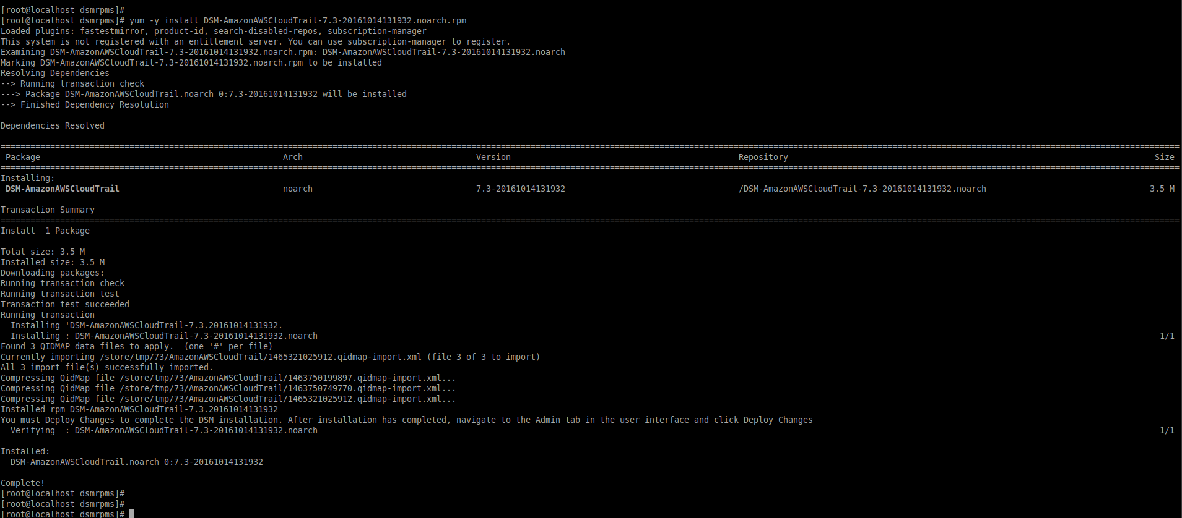

5) login to qradar console and deploy the changes

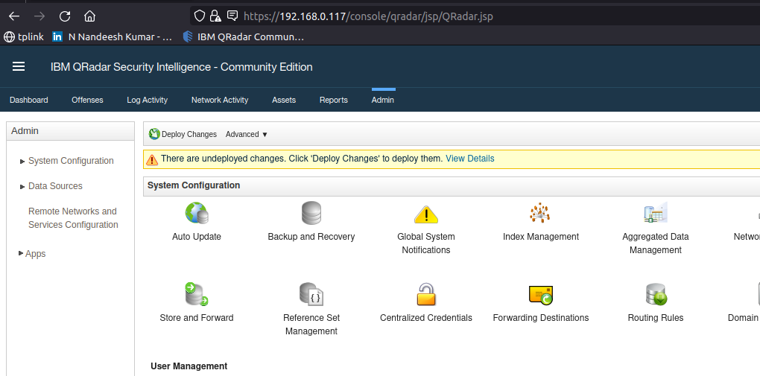

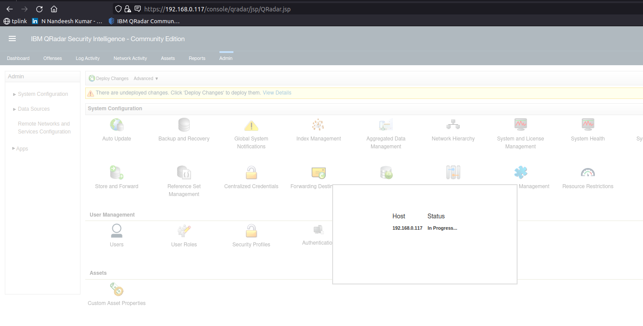

restart the web service if required.

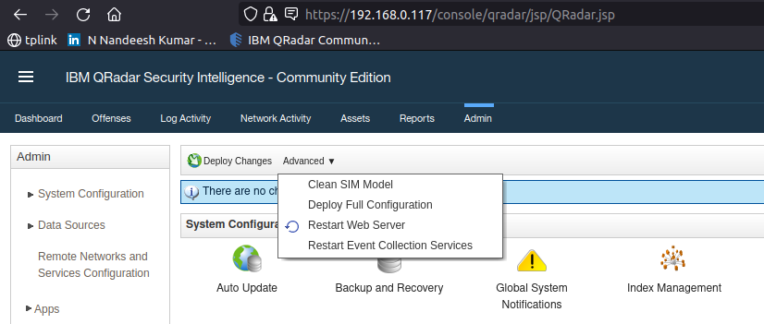

6. search for the newly installed DSM under the DSM editor

